DIABETES AGE VS BP
CODE:
Scatterplot:
diabetes <- read.csv("C:/R programming/diabetes (1).csv")
plot(diabetes$Age, diabetes$BloodPressure,
main = "Blood Pressure vs Age",
xlab = "Age",
ylab = "Blood Pressure",
pch = 19,
col = "blue")
OUTPUT:
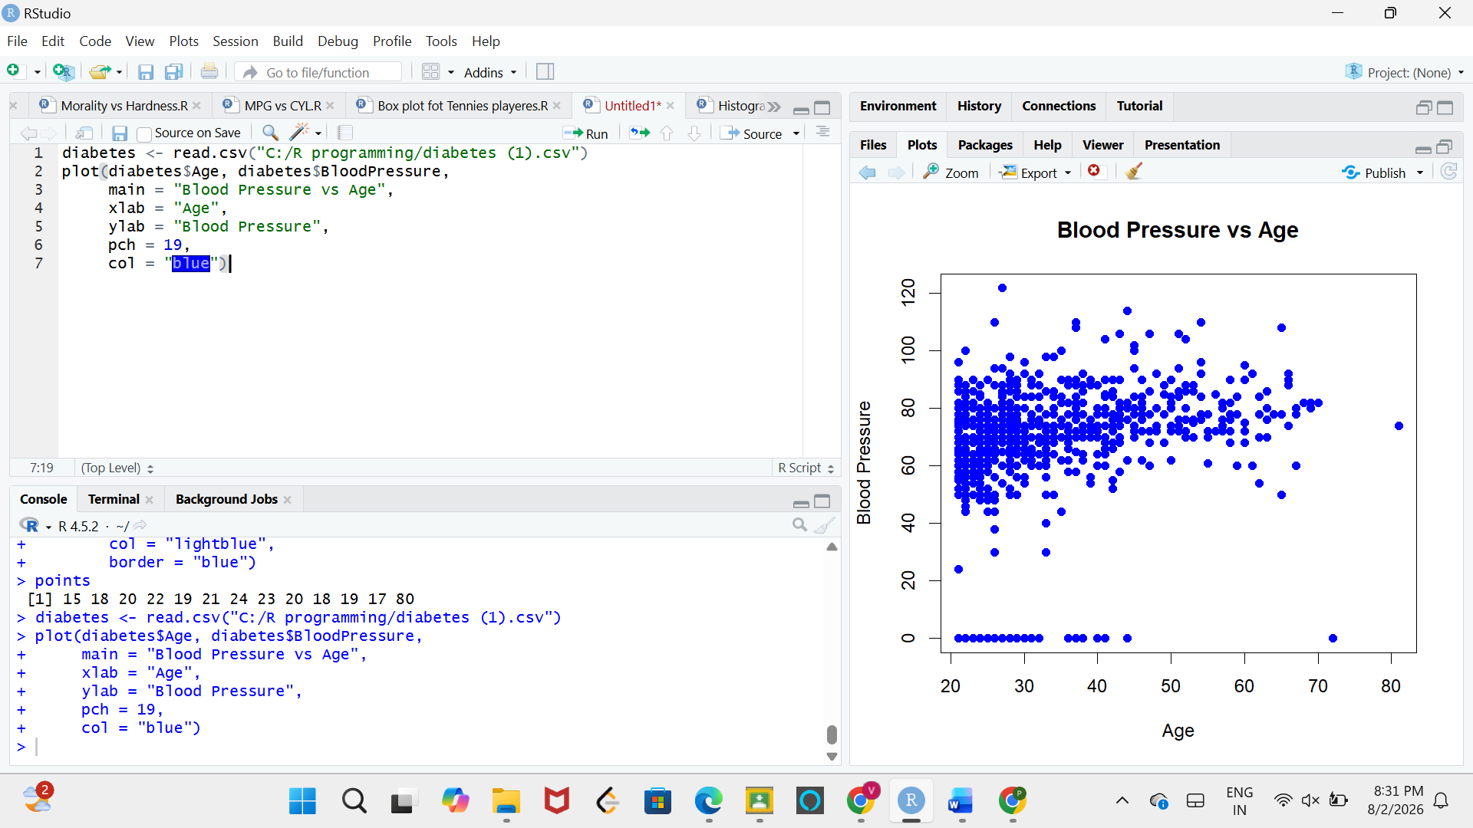

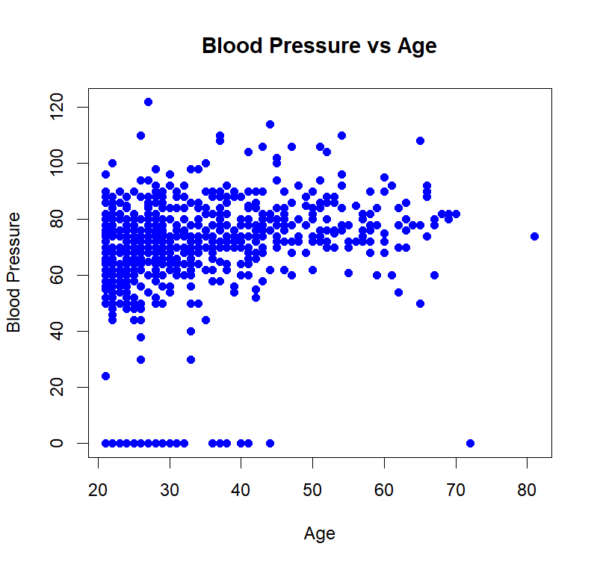
CODE:
Barplot:
diabetes$AgeGroup <- cut(diabetes$Age,
breaks = c(20,30,40,50,60,70,80),
labels = c("21-30","31-40","41-50","51-60","61-70","71-80"),
include.lowest = TRUE)
head(diabetes)
bp_age <- aggregate(BloodPressure ~ AgeGroup,
data = diabetes, FUN = mean)
bp_age
barplot(bp_age$BloodPressure,
names.arg = bp_age$AgeGroup,
main = "Average Blood Pressure by Age Group",
xlab = "Age Group",
ylab = "Average Blood Pressure",
col = "lightgreen",
border = "black")
OUTPUT:
